Do you open and read the Bulletin,
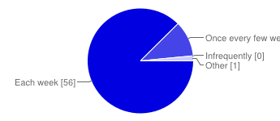 | Each week 56 88%  Once every few weeks 7 11%  Infrequently 0 0%  Other 1 2%

Do you forward the Lakes Hub Bulletin on to others?
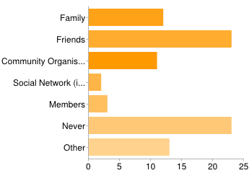 | Family 12 19%  Friends 23 36%  Community Organisation 11 17%  Social Network (ie Facebook, Twitter) 2 3%  Members 3 5%  Never 23 36%  Other 13 20%  People may select more than one checkbox, so percentages may add up to more than 100%.

Has the Lakes Hub Bulletin... - Increased your knowledge of local flora, fauna and weeds?
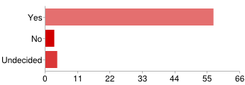 | Yes 57 89%  No 3 5%  Undecided 4 6%

Has the Lakes Hub Bulletin... - Increased your knowledge of history in the region?
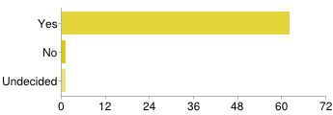 | Yes 62 97%  No 1 2%  Undecided 1 2%

Has the Lakes Hub Bulletin... - Encouraged you to participate in environmental projects, events, activities and training?
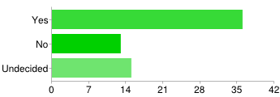 | Yes 36 56%  No 13 20%  Undecided 15 23%

Has the Lakes Hub Bulletin... - Given you a better understanding of the cultural significance of the region to the Ngarrindjeri people?
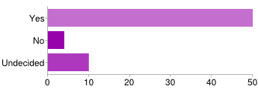 | Yes 50 78%  No 4 6%  Undecided 10 16%

Has the Lakes Hub Bulletin... - Connected you to other groups or organisations working in the region?
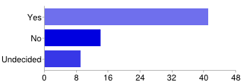 | Yes 41 64%  No 14 22%  Undecided 9 14%

Has the Lakes Hub Bulletin... - Improved you understanding of the environment and issues in the Coorong, Lower Lakes and Murray Mouth (CLLMM) region?
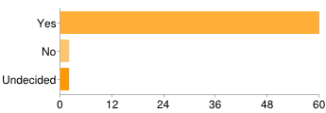 | Yes 60 94%  No 2 3%  Undecided 2 3%

Has the Lakes Hub Bulletin... - Encouraged you to share your skills, expertise and learning with the wider community?
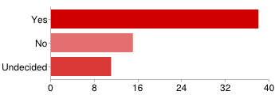 | Yes 38 59%  No 15 23%  Undecided 11 17%

Has the Lakes Hub Bulletin... - Made you feel more up to date about what's happening in the region?
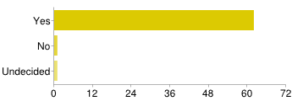 | Yes 62 97%  No 1 2%  Undecided 1 2%

Has the Lakes Hub Bulletin... - Assisted you to change the way you manage your business, do your work or volunteering?
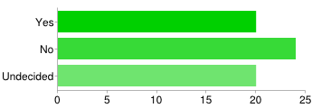 | Yes 20 31%  No 24 38%  Undecided 20 31%
Are there any other topics, subjects or training that you would like to see included?
Regional economic development and ideas for sustainability.More links to Murray Valley Standard stories... but I'm biased in that respect.Your newsletter is useful. However a glaring omission is the actual flow (in GL) of the R Murray into SA & the number of barrages open at the bottom end. Years ago, I asked the Hub to include these important data, year-round, but was deflected to a govt website.... this govt website didn't work, .... so no flow nor barrage info. Map showing location of Hubs and opening ours.Raptor identification and habitat workshopInformation on how the Ngarrindjeri used...
What is your preferred way of keeping up-to-date with the projects happening in the Coorong, Lower Lakes and Murray Mouth (CLLMM) region?
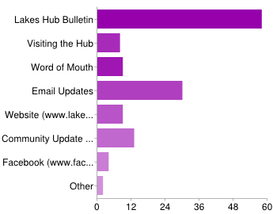 | Lakes Hub Bulletin 58 91%  Visiting the Hub 8 13%  Word of Mouth 9 14%  Email Updates 30 47%  Website (www.lakeshub.com) 9 14%  Community Update - Department of Environment, Water and Natural Resources 13 20%  Facebook (www.facebook.com/LakesHub) 4 6%  Other 2 3%  People may select more than one checkbox, so percentages may add up to more than 100%.

Have you contacted any other organisation regarding environmental issues in the Coorong, Lower Lakes and Murray Mouth (CLLMM) region
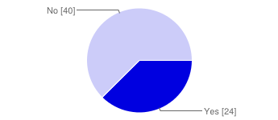 | Yes 24 38%  No 40 63%
If yes, who?
Goolwa to Wellington LAPG-W LAPsamdnrmbAlexandrina CouncilNRM BoardState Government, Federal Government, Coorong LAPNumerousADL Uni, dSEWPaC, MDBA, Federal & State Environment Ministers, Wentworth...
What other news sources do you regularly use?
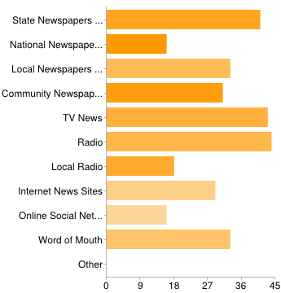 | State Newspapers (Advertiser, Sunday Mail) 41 64%  National Newspapers (The Australian...) 16 25%  Local Newspapers (Southern Argus, Victor Harbor Times etc...) 33 52%  Community Newspapers (Milang Community News, The Lakelander etc.. ) 31 48%  TV News 43 67%  Radio 44 69%  Local Radio 18 28%  Internet News Sites 29 45%  Online Social Networks (Facebook, Twitter etc) 16 25%  Word of Mouth 33 52%  Other 0 0%  People may select more than one checkbox, so percentages may add up to more than 100%.
Any other feedback about the Lakes Hub Bulletin?
I regularly take snippets from the Bulletin to put into my Weekly Update and appreciate the items from the Update that are in the Bulletin. Great newsletter, look forward to reading it every week, thankyou.Keep up the good work!I think it is good for a regional coverage in the lakes area...well done. I think it's a great way to keep up to date with what's happening around the LakesA great publications providing good advice to its constituents. I think it is a great publication and worthy of a wider distributionI find the Lakes Hub Bulletin, informative in regards to the Lower Lakes, Coorong ...
If you are not currently on the Lakes Hub database and would prefer to receive the weekly Lakes Hub Bulletin and other relevant announcements directly from the Lakes Hub, please type your email address in the box below
choppower@bigpond.comgerryowen@hotmail.com

To go into the draw to win a trip for 2 on the Spirit of the Coorong please enter your name and contact number below:
Name:
Harry BeauchampSean MoranDebbie WilkinsonKarenMike RobertsCon BoermaJoanne FlavelPeri StrathearnMatt PatonPeter SaintMargaret WIlkschHugh GoodenMichael CamacKerri Bartleydavid lohmeyerLyntonWendy Zi...
Contact Phone Number:
8532913442883913985329113 (work)08 827815874071188210427 970 375857512004198271244094773224287550264149188990400 388 54445779433040732513008 836406354390850114277110448555 4223855227304296532250455 ...
Number of daily responses
